Accounting

- Accounting module ensures to be the best and efficient tool for accounting processes.
- Its management can make a direct impact on the profit of the company and at the same time reduce losses.
- The major function of Accounting module are:
- Managing customer invoices
- Managing vendor bills
- Payments
- Follow up operations
- Budget management
- Quick reconciliation

To create employee expence

Accounting -> Vendor -> Employee Expenses -> Create

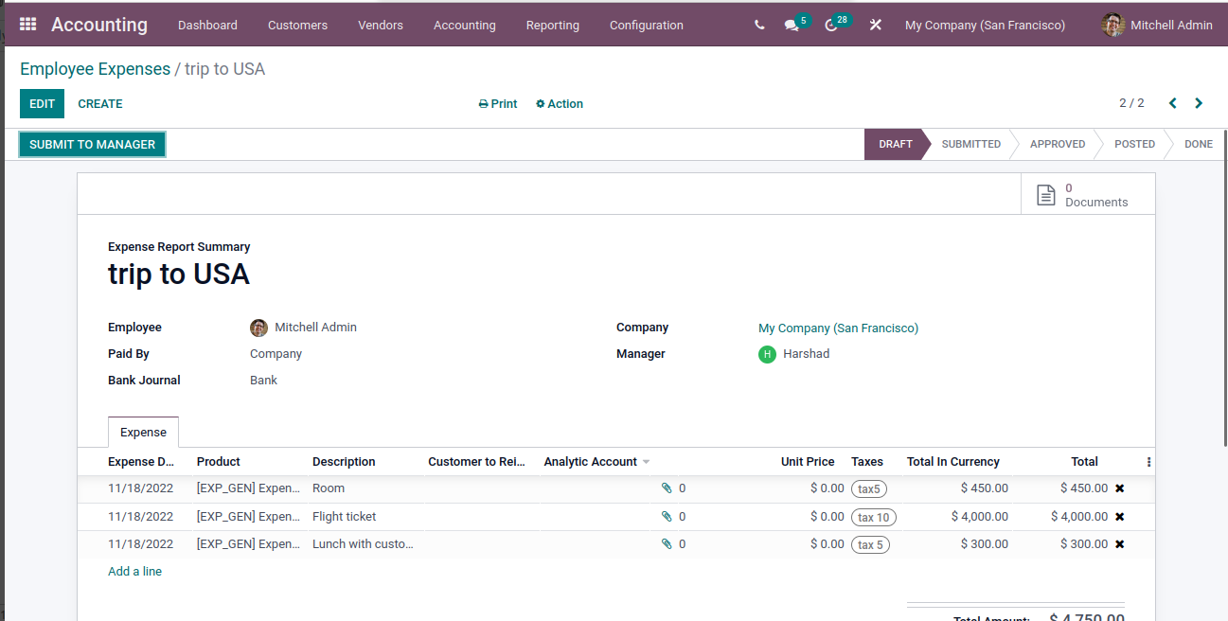
After submit to manager your expense will approved by the manage and you will confirmation
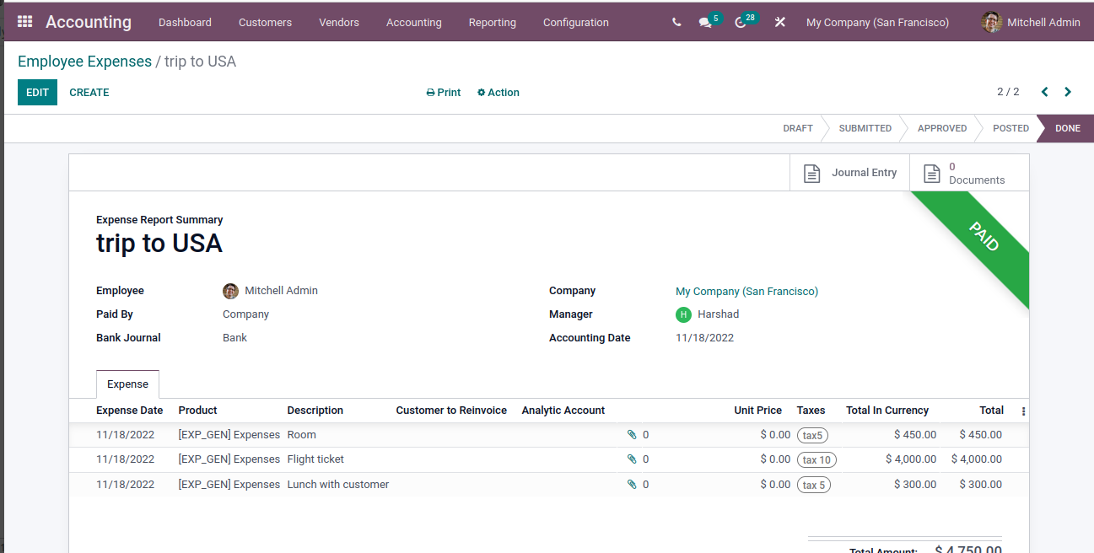

Credits note
- A credit note, or credit memo, is a document issued to a customer that notifies them that they have been credited a certain amount.
- There are several reasons that can lead to a credit note, such as:
- a mistake in the invoice
- a return of the goods, or a rejection of the services
- the goods delivered are damaged
To create Credit Note
Accounting -> Customers -> Credit Notes ->
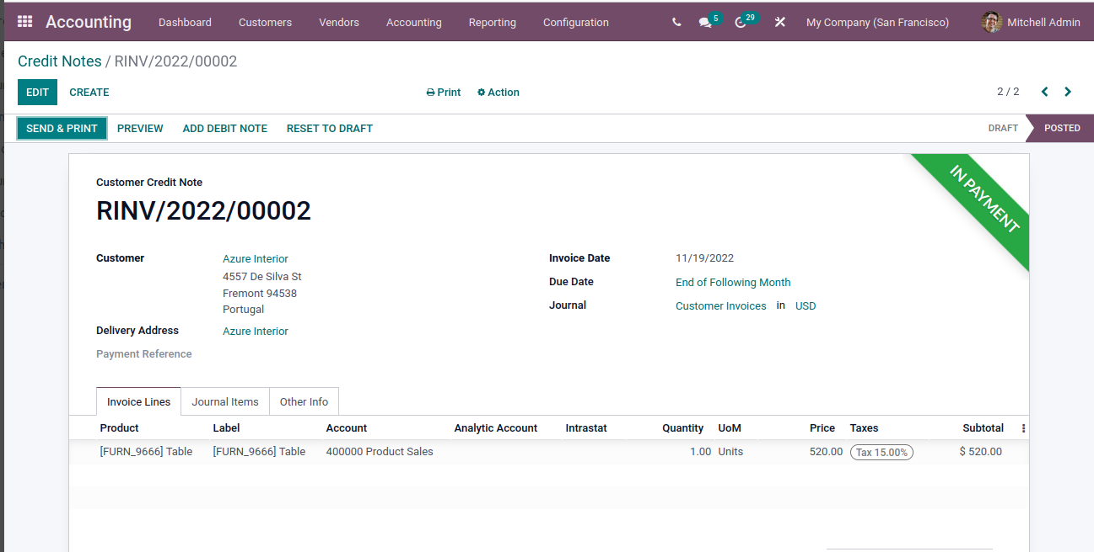
Batch Payments
- With Odoo batch payment mechanism, a user can process a group of transactions together.
- This will help to complete the processing of multiple bank transactions in a single step.

There are two types of batch payment

- Inbound batch type
The inbound batch type is a type of batch that us used to batch or group customer payments. If we chose inbound batch type we can only batch customer payments. Batching is done by selecting multiple payments and batching the payments.

2. Outbound batch type
It is a method used for batch payment. We can view only the vendor payments using this. This also helps to select multiple payments and use it as a batch.

Journal Entries

In Odoo, journal entries are made by utilizing the double entry bookkeeping system. Double Entry Bookkeeping Systems require you to make at least one debit line and at least one credit line for each entry. In addition, the totals of the credit side and the debit side of an entry must be of equal value.
In Odoo, these credit and debit lines that make up Journal Entries are called Journal Items.

General Ledger

In the Odoo 15 Accounting module you can view your company's general ledger by selecting the General Ledger option from the Accounting module. The ledger with details such as Date, Journal Entry, Label, Amount in Currency, Debit amount, Cdit amount, Balance, Cumulated Balance and Matching can be viewed.

Partner Ledger

The partner ledger shows receivable and payable journal entries of the partners. The debits and credits of individual partners can be evaluated and viewed with the help of partner ledgers. In Odoo you can view the partner ledger by selecting the Partner Ledger option from the Reporting tab.

Automatic Transfers

Automatic Transfers in the Accounting application of Odoo 15. Automatic Transfers, as the name implies, are scheduled transfers you can set up in Odoo to help automate your bookkeeping processes. Transfers are calculated by percentage and not by dollar amount, and will move that percentage of the balance from the related period.

Deferred Revenues

Deferred revenue is the advance payment which has been recorded under the liability account of the beneficiary until an internal task is triggered on the product conveyance.

Deferred Expenses

Deferred expenses are payments made in advance by our company for our service products for insurance or home rent, etc . yet to render. Such payments are assets for the company that receives them since it still owes its customers these products or services.

